Victoria Hong

IPSA

Longitudinal Dynamic Stability of Airplane D case 2

Equations of longitudinal motion, Different modes of longitudinal stability (Short period, Phugoid mode), Curves, Transfer functions

DM Mécanique du VOL

M. Yazigi

Summary

Equations of longitudinal motion. 3

The matrix A of aircraft 5

The characteristic equation 6

The eigenvalues (roots of equation) of the system 7

Different modes of longitudinal stability 7

Curves of longitudinal motion: 8

Transfer Functions of Each variable 10

# Equations of longitudinal motion

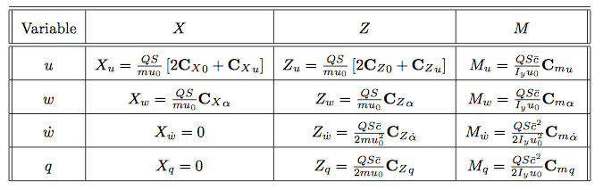

We make the calculations of all components of matrix A:

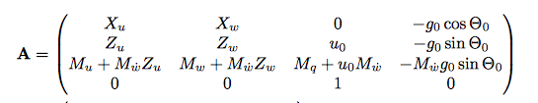

$$ρ=air density =0.000588×515.383=0.3030$$

$$U_{0}=speed=677×0.3048=206.3496 m/s$$

$$\overline{q}=\frac{1}{2}ρU_{0}^{2}=\frac{1}{2}×0.3030×({206.3496)}^{2}=12 903.7038$$

$$a=\sqrt{γR_{s}T}$$

$$a=\sqrt{1.4×287×216.5}$$

$$a=294.94 m/s$$

$$M=\frac{U_{0}}{a}=0.7$$

$$S=wing area=230×{(0.3048)}^{2}=21.3677 m^{2}$$

$$b=wing span=34×0.3048=10.36$$

$$m=weight= 13 000 ×0.453592$$

$$X_{u}=-\frac{\overline{q}S}{mU_{0}} \left[2C_{D_{0}}+MC_{D_{M}}\right]=-\frac{12 903.7 × 21.3677}{5896.7×206.35}× \left[2×0.0335+0.7×0.0715\right]$$

$X_{u}=$**-0.0133**

$$X_{w}=\frac{\overline{q}S}{mU_{0}} \left(C_{L_{0}}-\frac{2}{π e AR}\left(C_{L_{0}}\frac{∂C_{L}}{∂α}\right)\right)=\frac{\overline{q}S}{mU_{0}} \left(C_{L_{0}}-\frac{2}{π e AR}\left(C_{L_{0}}C_{L_{α}}\right)\right)$$

$$AR=Aspect ratio=\frac{b^{2}}{S}=\frac{{(10.36)}^{2}}{21.3677}=5.0269$$

$$X_{w}=\frac{12 903.7 × 21.3677}{5896.7×206.35}× \left(0.41-\frac{2}{3.14×0.85×5.0269}(0.41×5.84)\right)$$

$$X_{w}=0.0060$$

$$Z_{u}=-\frac{\overline{q}S}{mU_{0}} \left[(2C_{L_{0}}+\frac{M^{2}}{1-M^{2}}C_{L_{0}})\right]=-\frac{12 903.7 × 21.3677}{5896.7×206.35}×\left(2×0.41+\frac{{0.7}^{2}}{1-{0.7}^{2}}0.41\right)$$

$$Z_{u}=-0.1374$$

$$Z_{w}=-\frac{\overline{q}S}{mU_{0}} \left[{(C}_{D_{0}}+C_{L_{α}})\right]=-\frac{12 903.7 × 21.3677}{5896.7×206.35}×\left(0.0335+5.84\right)$$

$$Z_{w}=-0.6655$$

$$\overline{C}=\frac{7}{0.3048}=2.1336$$

$$Z_{\dot{w}}=\frac{\overline{q}S\overline{C}}{2m{U_{0}}^{2}} \left[(C_{D_{1}}+C_{L_{\dot{α}}})\right]=\frac{12 903.7 × 21.3677×2.1336}{2×5896.7×{(206.35}^{)2}}×\left(0.0298+2.5\right)$$

$$Z_{\dot{w}}=0.0013$$

$$Z_{q}=\frac{\overline{q}S\overline{C}}{2mU_{0}} \left[C_{L_{q}}\right]=\frac{12 903.7 × 21.3677×2.1336}{2×5896.7×206.35}×4.7$$

$$Z_{q}=0.5681$$

$$I_{yyB}=18 800×1.3558=25489$$

$$M_{u}=\frac{\overline{q}S\overline{C}}{I_{yyB}U_{0}} \left[M C_{m_{M}} \right]=\frac{12 903.7 × 21.3677×2.1336}{25489×206.35}×0.7×0.1486$$

$$M_{u}=0.0058$$

$$M_{w}=\frac{\overline{q}S\overline{C}}{I_{yyB}U_{0}} \left[ C_{m_{α}} \right]=\frac{12 903.7 × 21.3677×2.1336}{25489×206.35}×\left(-0.64\right)$$

$$M_{w}=-0.0358$$

$$M_{\dot{w}}=\frac{\overline{q}S\overline{C^{2}}}{2I_{yyB}{U_{0}}^{2}} \left[ C_{m_{\dot{α}}} \right]=\frac{12 903.7 × 21.3677×{(2.1336)}^{2}}{2×25489×{(206.35)}^{2}}×\left(-6.7\right)$$

$$M_{\dot{w}}=-0.0019$$

$$M_{q}=\frac{\overline{q}S\overline{C^{2}}}{2I_{yyB}U_{0}} \left[ C_{m_{q}} \right]=\frac{12 903.7 × 21.3677×{(2.1336)}^{2}}{2×25489×{(206.35)}^{2}}×\left(-15.5\right)$$

$$M_{q}=-0.9247$$

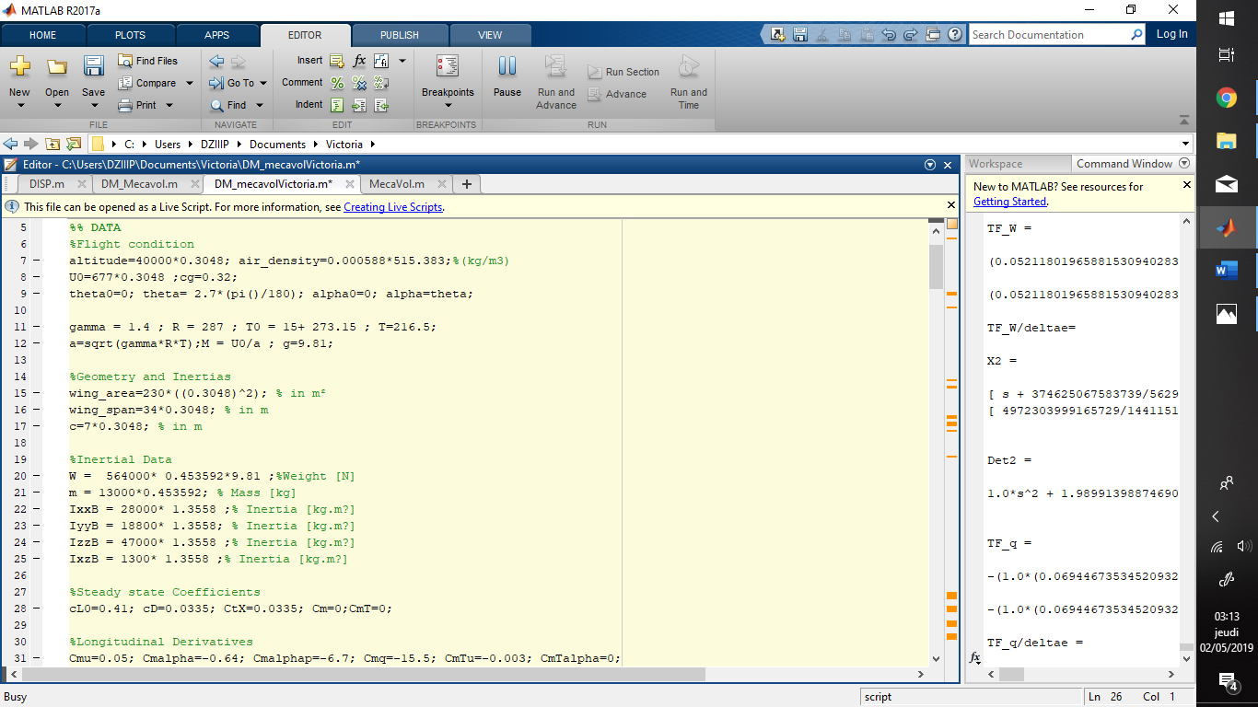

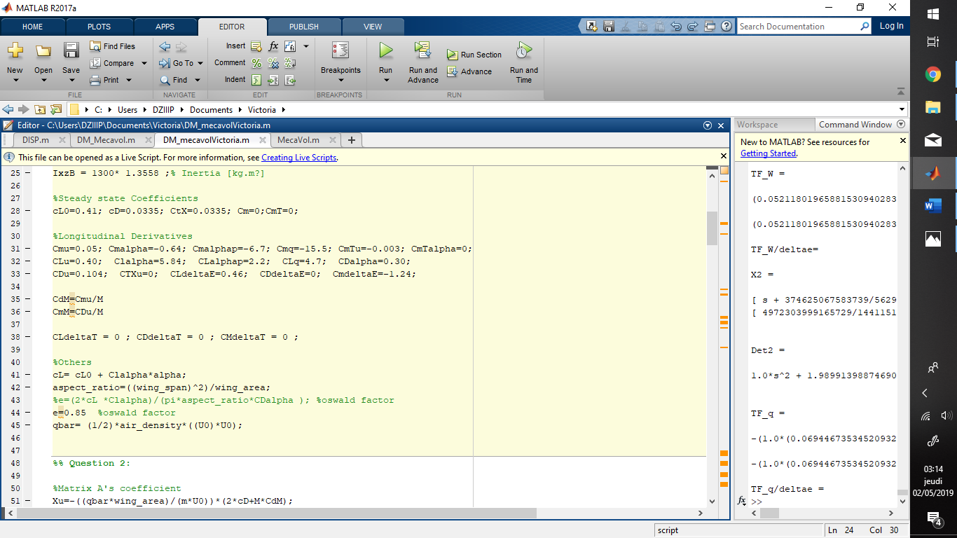

We implement the data of the airplane D. Then we can calculate the matrix A’s coefficients.

# 

# The matrix A of aircraft

$$A=\left(\begin{matrix}X_{u} & X_{w} & \begin{matrix}0 & -g_{0}\cos{θ_{0}}\end{matrix} \\ Z_{u} & Z_{w} & \begin{matrix}u_{0} & {-g}_{0}\sin{θ_{0}}\end{matrix} \\ \begin{matrix}M_{u}+M_{\dot{w}}Z_{u} \\ 0\end{matrix} & \begin{matrix}M_{w}+M_{\dot{w}}Z_{w} \\ 0\end{matrix} & \begin{matrix}\begin{matrix}M_{q}+{u_{0}M}_{\dot{w}} \\ 1\end{matrix} & \begin{matrix}{-M}_{\dot{w}}g_{0}\sin{θ_{0}} \\ 0\end{matrix}\end{matrix}\end{matrix}\right)$$

$$A=\left(\begin{matrix}-0.0133 & 0.0060 & \begin{matrix}0 & -9.81\end{matrix} \\ -0.1374 & -0.6655 & \begin{matrix}206.3496 & 0\end{matrix} \\ \begin{matrix}0.0061 \\ 0\end{matrix} & \begin{matrix}-0.0345 \\ 0\end{matrix} & \begin{matrix}\begin{matrix}-1.3244 \\ 1\end{matrix} & \begin{matrix}0.0009 \\ 0\end{matrix}\end{matrix}\end{matrix}\right)$$

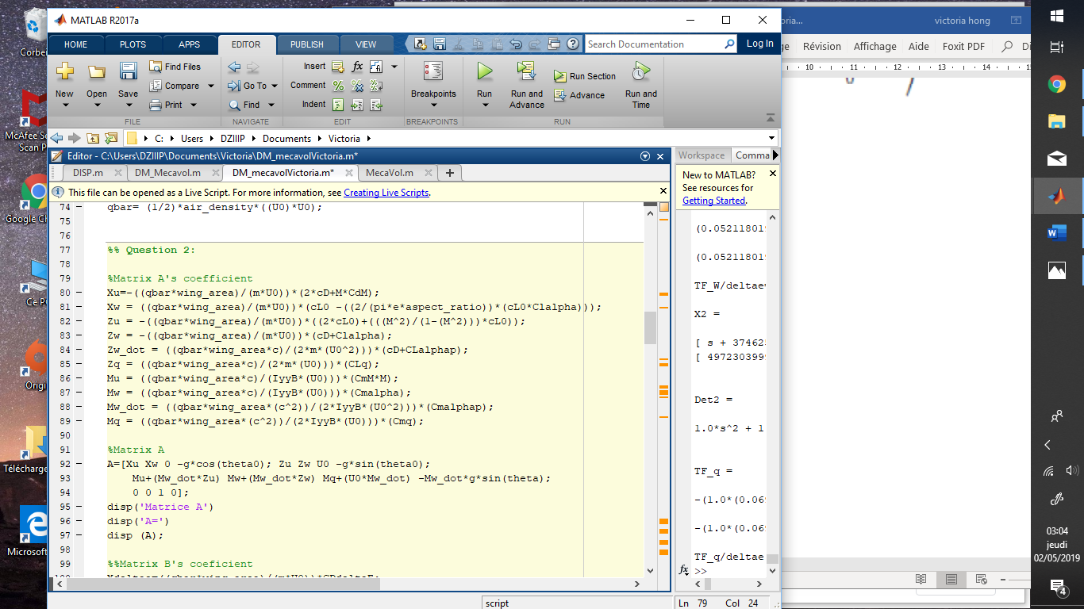

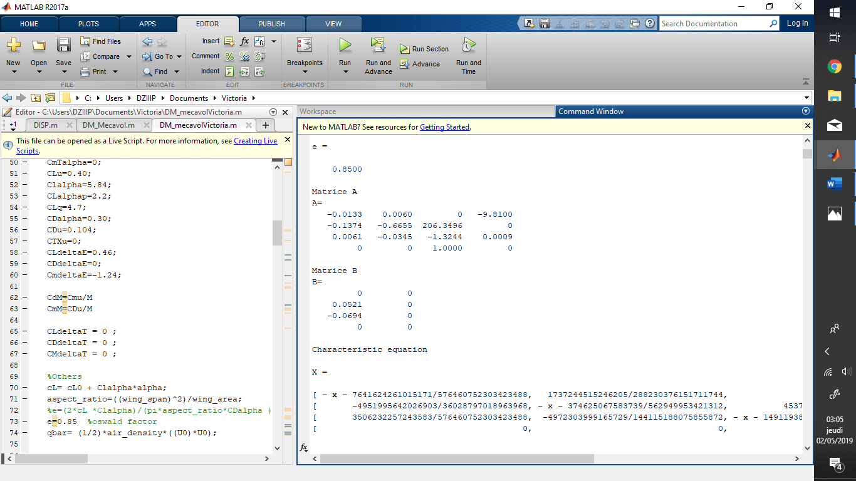Results:

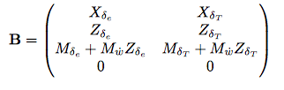

**Program**

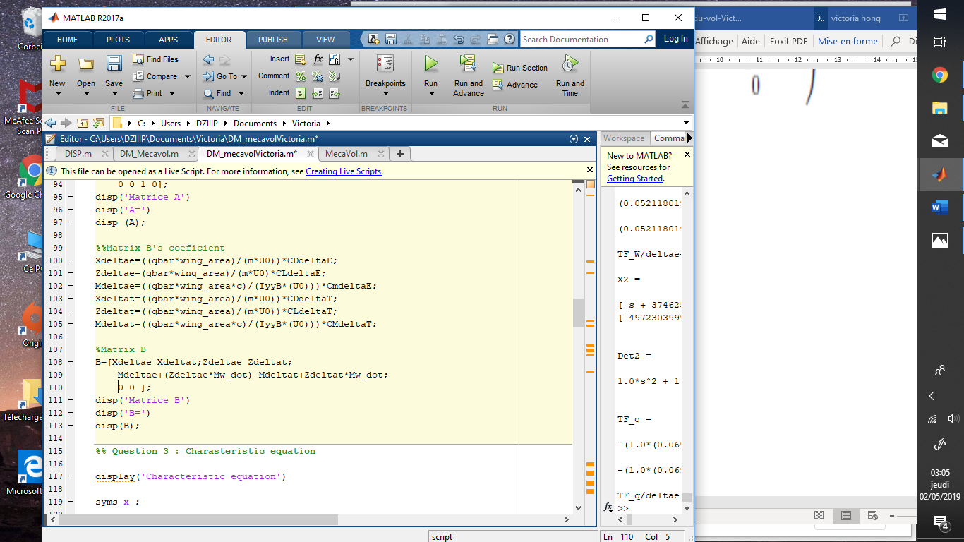

**Results**

# 

# The characteristic equation

The characteristic equation is given by : ../Desktop/Capture%20d’écran%202019-05-02%20à%2020.06.55.png

With Matlab, we will have the coefficients and the equation.

**Program**

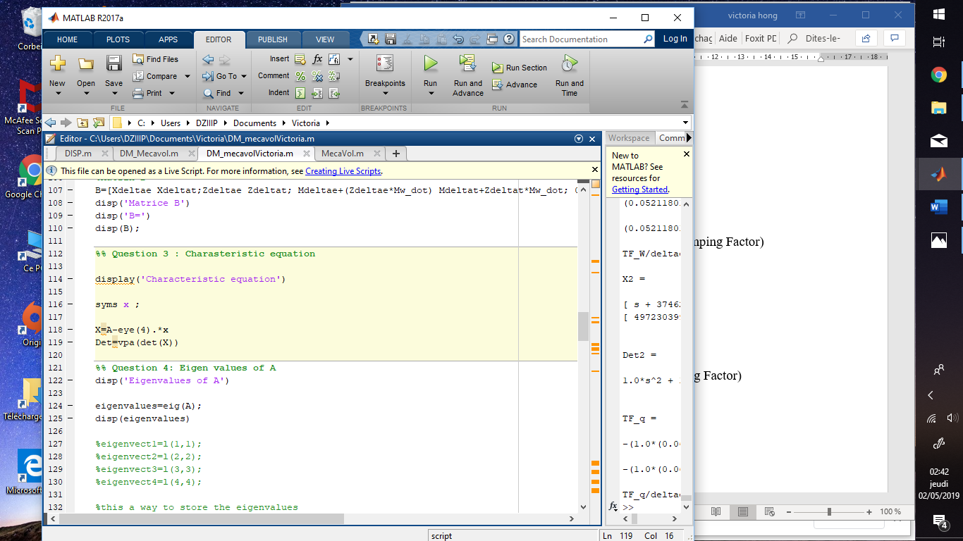

We have the following characteristic equation :

$$λ^{4}+2.0031λ^{3}+8.0273λ^{2}+0.1587λ+0.0862=0$$

# The eigenvalues (roots of equation) of the system

The eigenvalues and the eigenvector can be obtained in matlab by the command eig(A).

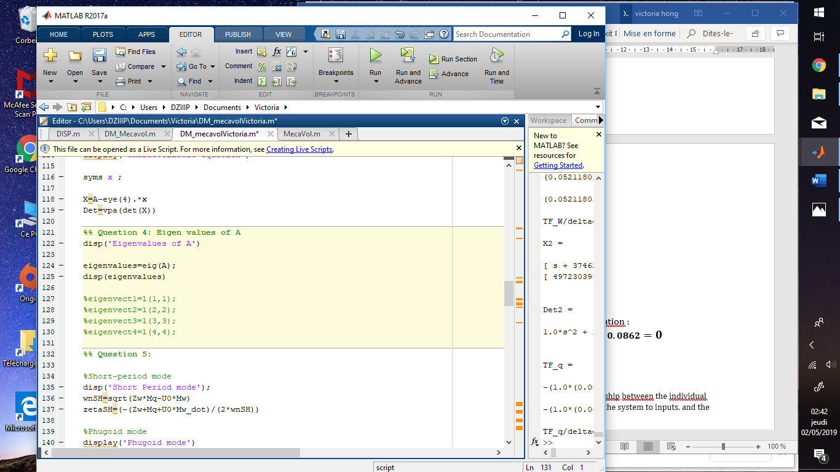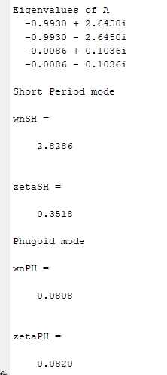

The characteristic equation admits those complex roots:

$$λ_{1}=-0.993+2.643i$$

$$λ_{2}=-0.993-2.643i$$

$$λ_{3}=-0.0086+0.104i$$

$$λ_{4}=-0.0086-0.104i$$

The eigenvalues are negative that is to say that all movements will be damped. The eigenvalues $λ_{1}$ and $λ_{2}$ should be damped faster because they are higher than the others.

# Different modes of longitudinal stability

The first complex root represents a high-frequency, highly-damped oscillation called the **short-period mode**, and the second complex root represents a low-frequency, lightly-damped oscillation called the **phugoid mode**. Both modes are stable.

### Short period mode (Natural Frequency, Damping Factor)

From the eigenvalues, we have $λ_{1,2}=-0.993±2.643i$.

The natural frequency of short period is:

$$ω_{nSP} =\frac{{- ε}_{SP}}{ζ_{SP}}= 2.8242 rad/s$$

The damping ratio mode is:

$$ζ_{sp}= \sqrt{\frac{1}{1+{\left(\frac{η}{ε}\right)}_{SP}^{2}}}= \sqrt{\frac{1}{1+{\left(\frac{2.643}{-0.993}\right)}_{SP}^{2}}}=0.3517$$

The period is:

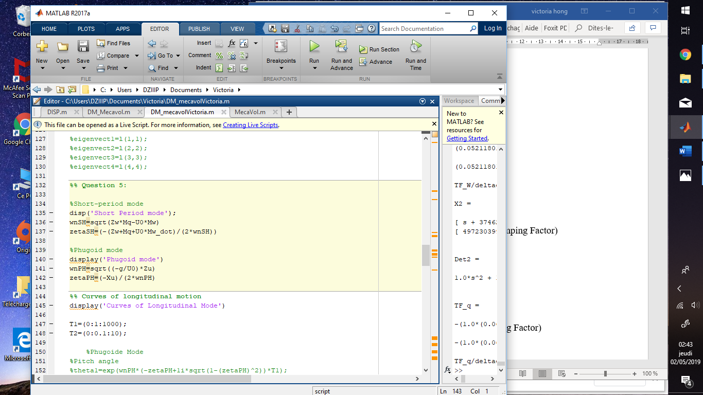

### 

### Phugoid mode (Natural Frequency, Damping Factor)

From the eigenvalues, we have : $λ_{3,4}=-0.0086±0.104i$

The natural frequency of short period is:

$$ω_{nP} =\frac{{- ε}_{SP}}{ζ_{SP}}=0.1039 rad/s$$

The damping ratio mode is:

$$ζ_{p}= \sqrt{\frac{1}{1+{\left(\frac{η}{ε}\right)}_{P}^{2}}}= \sqrt{\frac{1}{1+{\left(\frac{0.104}{-0.0086}\right)}_{P}^{2}}}=0.0824$$

The period is:



# Curves of longitudinal motion:

Curve of longitudinal function with Phugoid mode:

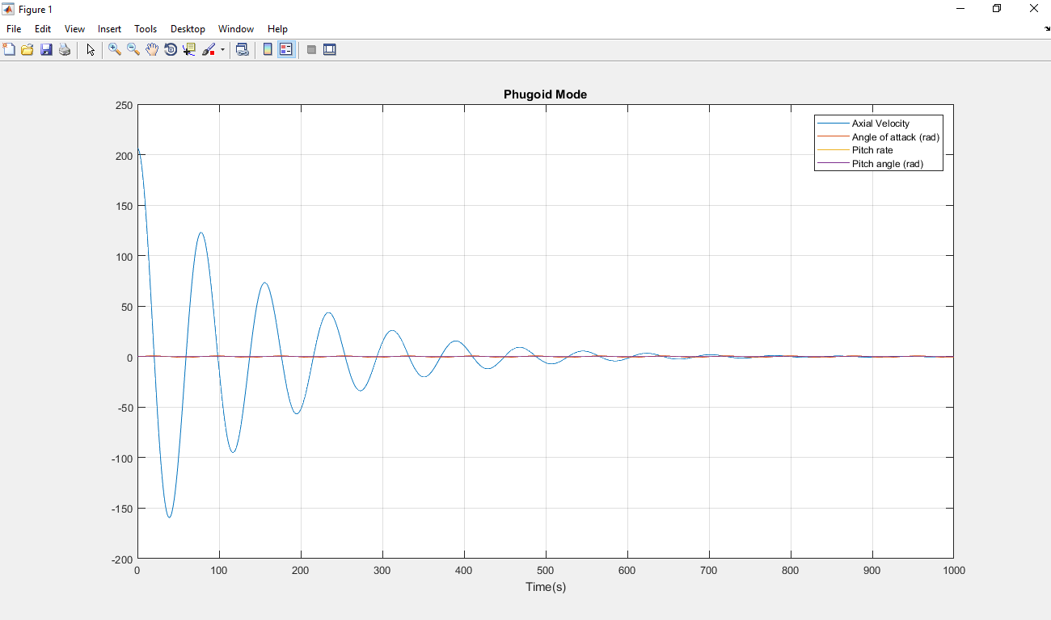

The airplane begins to damp the perturbation in less than 8 minutes 20 secondes. The curve decreases rapidly.

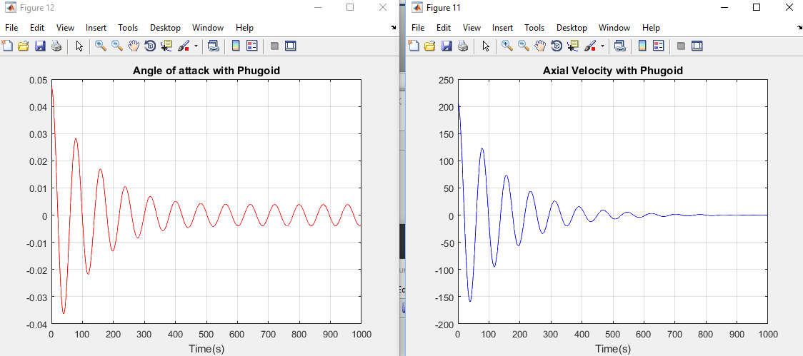

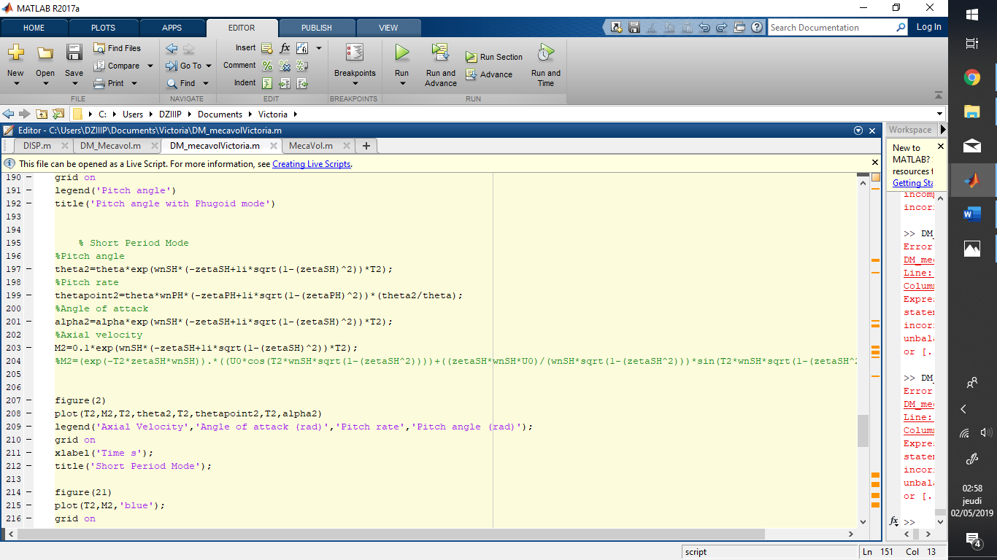

Curve of longitudinal function with short period:

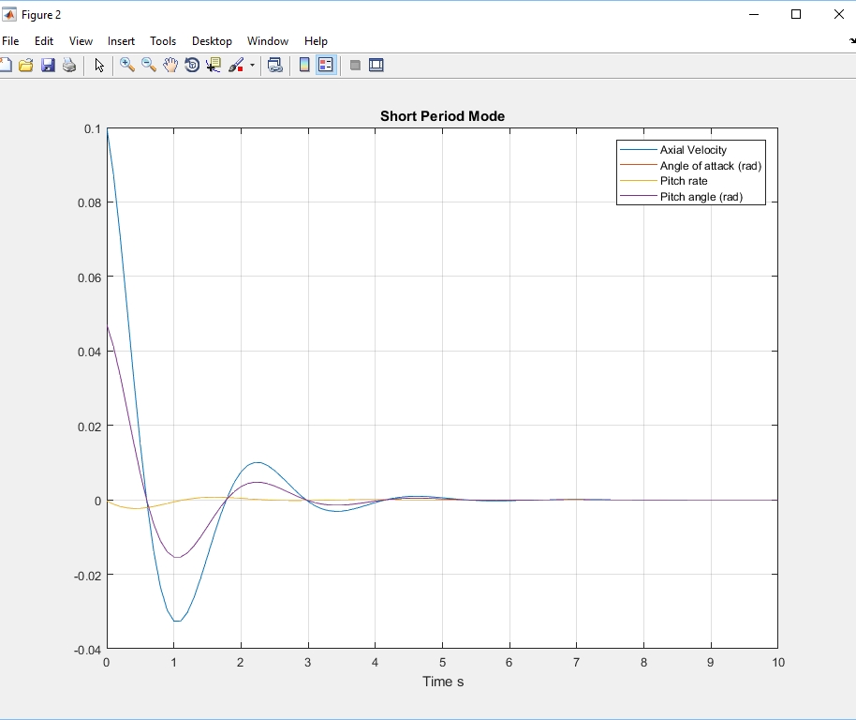

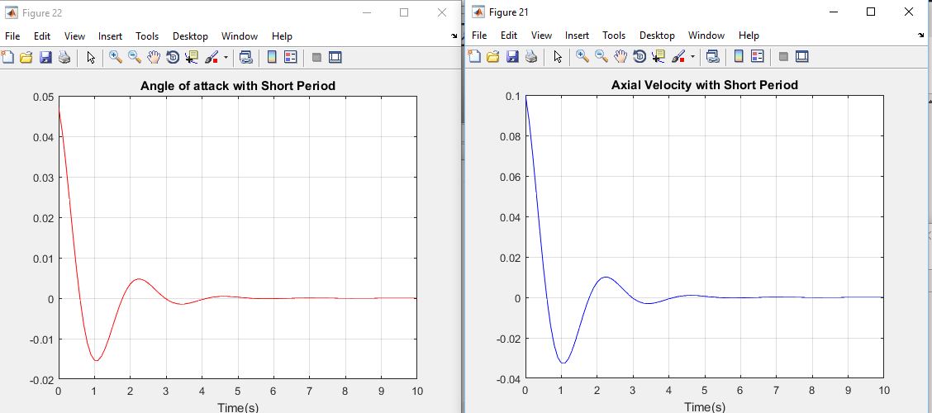

# Transfer Functions of Each variable

### Phugoid approximation

$$A=\left(\begin{matrix}-1.32E-02 & -9.81 \\ 6.66E-04 & 0\end{matrix}\right)$$

**Program**

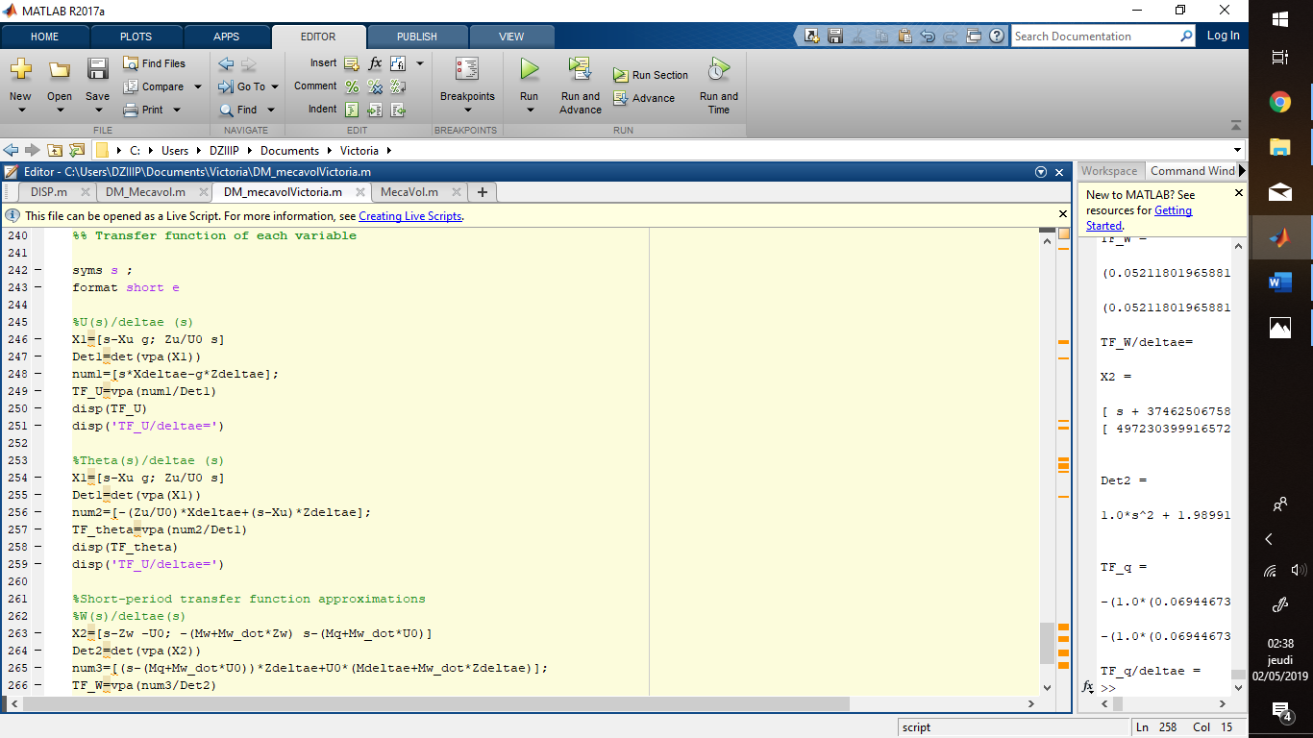

**Results:**

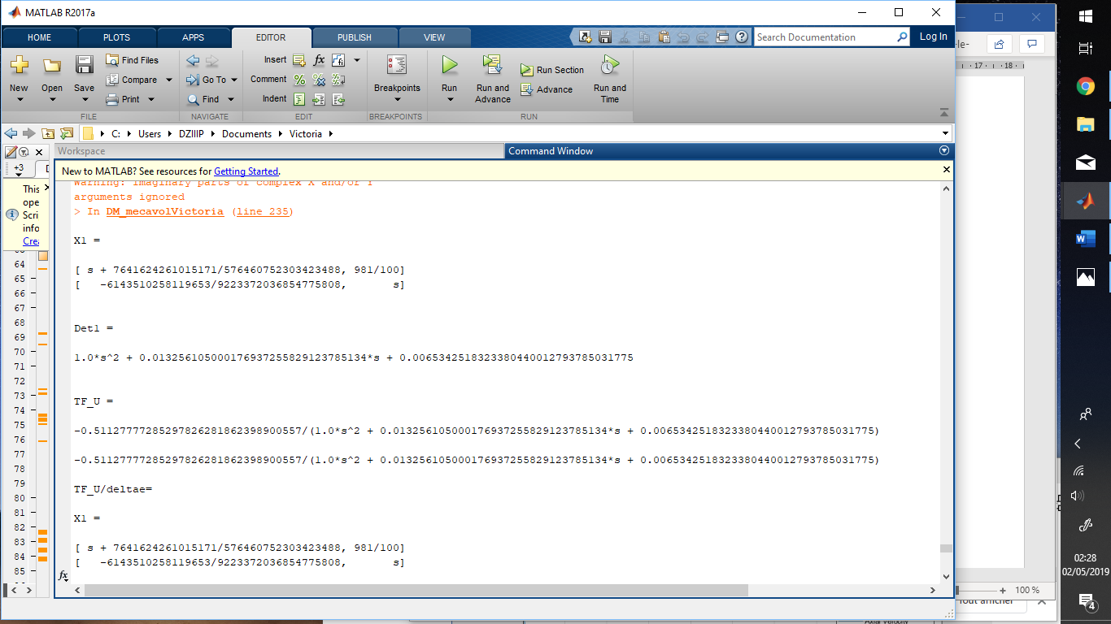

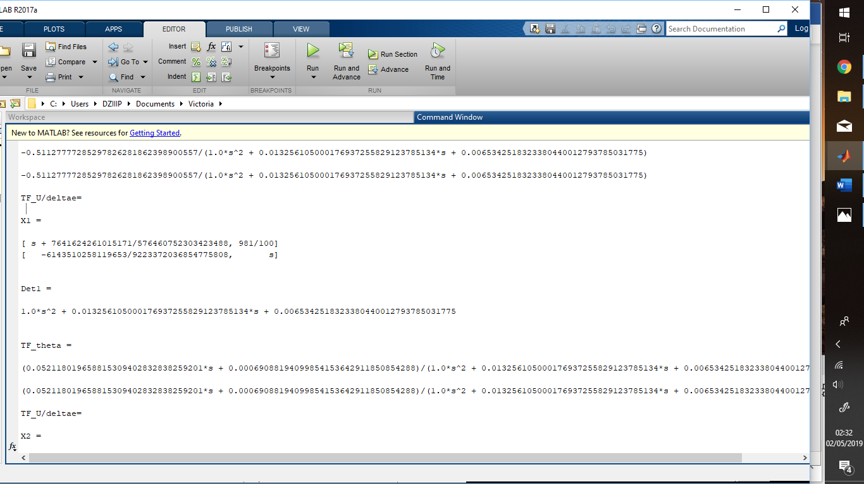

The characteristic function is: $$s^{2}+0.0132 s+0.0065$$

The transfer function are:

$$\frac{U(s)}{δ_{e}(s)}=\frac{-0.5112}{s^{2}+0.01326s+0.00654}$$

$\frac{θ(s)}{δ_{e}(s)}=\frac{0.0521×\left(s+0.01325\right)}{s^{2}+0.1326s+0.00654}=\frac{0.0521s+0.000690}{s^{2}+0.1326s+0.00654}$

### Short Period approximation

$$A=\left(\begin{matrix}-0.665 & 206.349 \\ -0.0345 & -1.324\end{matrix}\right)$$

**Program**

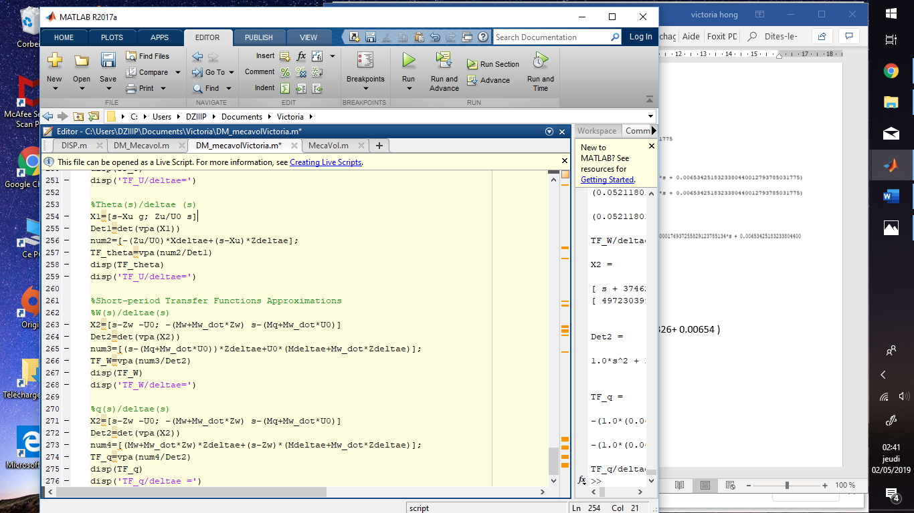

**Results :**

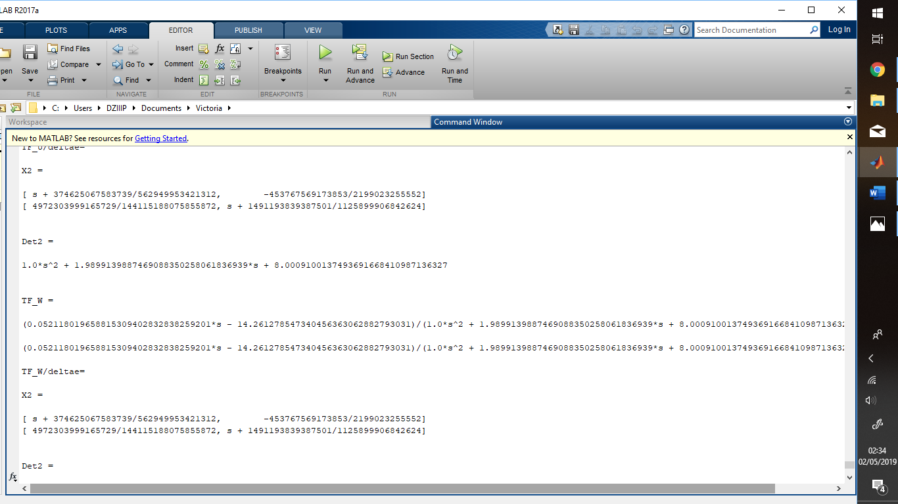



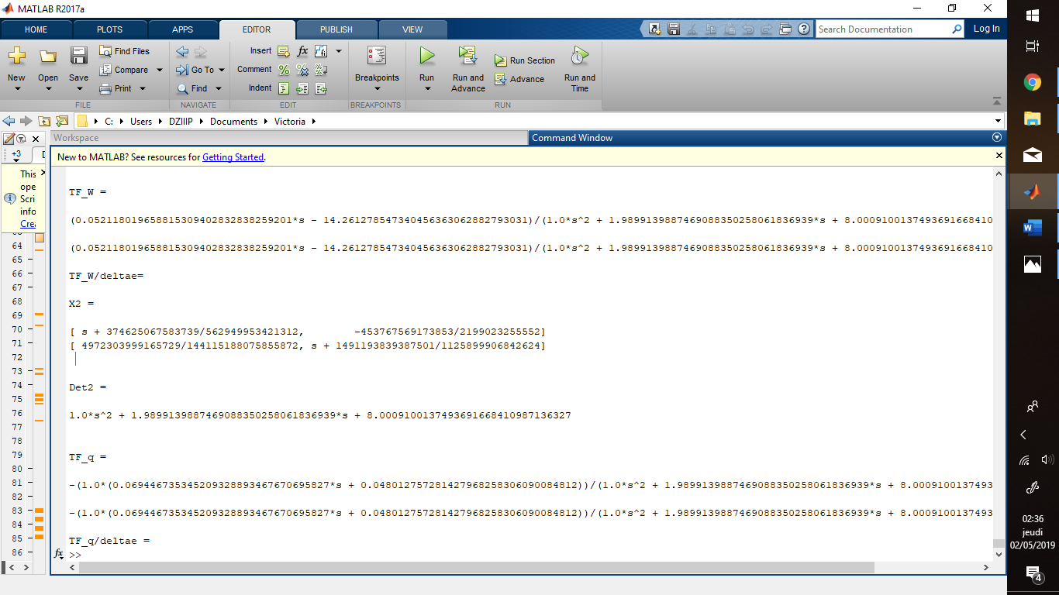

The characteristic function is:

$$s^{2}+1.989 s+8.001$$

The transfer function with short period are:

$$\frac{ω(s)}{δ_{e}(s)}=\frac{0.0521×\left(s+0.525\right)-14.309}{s^{2}+1.989s+8.001}$$

$$\frac{q(s)}{δ_{e}(s)}=\frac{-0.0693×\left(s+0.665\right)-0.00179}{s^{2}+1.989s+8.001}$$

# Annexe (code)

clc

clear all

format short

%% DATA

%Flight condition

altitude=40000*0.3048; air_density=0.000588*515.383;%(kg/m3)

U0=677*0.3048 ;cg=0.32;

theta0=0; theta= 2.7*(pi()/180); alpha0=0; alpha=theta;

gamma = 1.4 ; R = 287 ; T0 = 15+ 273.15 ; T=216.5;

a=sqrt(gamma*R*T);M = U0/a ; g=9.81;

%Geometry and Inertias

wing_area=230*((0.3048)^2); % in m²

wing_span=34*0.3048; % in m

c=7*0.3048; % in m

%Inertial Data

W = 564000* 0.453592*9.81 ;%Weight [N]

m = 13000*0.453592; % Mass [kg]

IxxB = 28000* 1.3558 ;% Inertia [kg.m?]

IyyB = 18800* 1.3558; % Inertia [kg.m?]

IzzB = 47000* 1.3558 ;% Inertia [kg.m?]

IxzB = 1300* 1.3558 ;% Inertia [kg.m?]

%Steady state Coefficients

cL0=0.41; cD=0.0335; CtX=0.0335; Cm=0;CmT=0;

%Longitudinal Derivatives

Cmu=0.05; Cmalpha=-0.64; Cmalphap=-6.7; Cmq=-15.5; CmTu=-0.003; CmTalpha=0;

CLu=0.40; Clalpha=5.84; CLalphap=2.2; CLq=4.7; CDalpha=0.30;

CDu=0.104; CTXu=0; CLdeltaE=0.46; CDdeltaE=0; CmdeltaE=-1.24;

CdM=Cmu/M

CmM=CDu/M

CLdeltaT = 0 ; CDdeltaT = 0 ; CMdeltaT = 0 ;

%Others

cL= cL0 + Clalpha*alpha;

aspect_ratio=((wing_span)^2)/wing_area;

%e=(2*cL *Clalpha)/(pi*aspect_ratio*CDalpha ); %oswald factor

e=0.85 %oswald factor

qbar= (1/2)*air_density*((U0)*U0);

%% Question 2:

%Matrix A's coefficient

Xu=-((qbar*wing_area)/(m*U0))*(2*cD+M*CdM);

Xw = ((qbar*wing_area)/(m*U0))*(cL0 -((2/(pi*e*aspect_ratio))*(cL0*Clalpha)));

Zu = -((qbar*wing_area)/(m*U0))*((2*cL0)+(((M^2)/(1-(M^2)))*cL0));

Zw = -((qbar*wing_area)/(m*U0))*(cD+Clalpha);

Zw_dot = ((qbar*wing_area*c)/(2*m*(U0^2)))*(cD+CLalphap);

Zq = ((qbar*wing_area*c)/(2*m*(U0)))*(CLq);

Mu = ((qbar*wing_area*c)/(IyyB*(U0)))*(CmM*M);

Mw = ((qbar*wing_area*c)/(IyyB*(U0)))*(Cmalpha);

Mw_dot = ((qbar*wing_area*(c^2))/(2*IyyB*(U0^2)))*(Cmalphap);

Mq = ((qbar*wing_area*(c^2))/(2*IyyB*(U0)))*(Cmq);

%Matrix A

A=[Xu Xw 0 -g*cos(theta0); Zu Zw U0 -g*sin(theta0);

Mu+(Mw_dot*Zu) Mw+(Mw_dot*Zw) Mq+(U0*Mw_dot) -Mw_dot*g*sin(theta);

0 0 1 0];

disp('Matrice A')

disp('A=')

disp (A);

%%Matrix B's coeficient

Xdeltae=((qbar*wing_area)/(m*U0))*CDdeltaE;

Zdeltae=(qbar*wing_area)/(m*U0)*CLdeltaE;

Mdeltae=((qbar*wing_area*c)/(IyyB*(U0)))*CmdeltaE;

Xdeltat=((qbar*wing_area)/(m*U0))*CDdeltaT;

Zdeltat=((qbar*wing_area)/(m*U0))*CLdeltaT;

Mdeltat=((qbar*wing_area*c)/(IyyB*(U0)))*CMdeltaT;

%Matrix B

B=[Xdeltae Xdeltat;Zdeltae Zdeltat;

Mdeltae+(Zdeltae*Mw_dot) Mdeltat+Zdeltat*Mw_dot;

0 0 ];

disp('Matrice B')

disp('B=')

disp(B);

%% Question 3 : Charasteristic equation

display('Characteristic equation')

syms x ;

X=A-eye(4).*x

Det=vpa(det(X))

%% Question 4: Eigen values of A

disp('Eigenvalues of A')

eigenvalues=eig(A);

disp(eigenvalues)

%eigenvect1=l(1,1);

%eigenvect2=l(2,2);

%eigenvect3=l(3,3);

%eigenvect4=l(4,4);

%% Question 5:

%Short-period mode

disp('Short Period mode');

wnSH=sqrt(Zw*Mq-U0*Mw)

zetaSH=(-(Zw+Mq+U0*Mw_dot)/(2*wnSH))

%Phugoid mode

display('Phugoid mode')

wnPH=sqrt((-g/U0)*Zu)

zetaPH=(-Xu)/(2*wnPH)

%% Curves of longitudinal motion

display('Curves of Longitudinal Mode')

T1=(0:1:1000);

T2=(0:0.1:10);

%Phugoide Mode

%Pitch angle

%theta1=exp(wnPH*(-zetaPH+1i*sqrt(1-(zetaPH)^2))*T1);

theta1=(exp(-T1*zetaPH*wnPH)).*(0*cos(wnPH*sqrt(1-(zetaPH^2))))+((zetaPH*wnPH*10)/(wnPH*sqrt(1-(zetaPH^2)))*sin(wnPH*sqrt(1-(zetaPH^2))*T1));

%Pitch rate

%thetapoint1=theta0*wnPH*(-zetaPH+1i*sqrt(1-(zetaPH)^2))*(theta1/theta0);

thetapoint1=(exp(-T1*zetaPH*wnPH)).*(0*cos(wnPH*sqrt(1-(zetaPH^2))*T1))+((zetaPH*wnPH)/(wnPH*sqrt(1-(zetaPH^2)))*sin(wnPH*sqrt(1-(zetaPH^2))*T1));

%Angle of attack

%alpha1=alpha0*exp(wnPH*(-zetaPH+1i*sqrt(1-(zetaPH)^2))*T1);

alpha1=(exp(-T1*zetaPH*wnPH)).*(theta*cos(wnPH*sqrt(1-(zetaPH^2))*T1))+((zetaPH*wnPH*theta)/(wnPH*sqrt(1-(zetaPH^2)))*sin(wnPH*sqrt(1-(zetaPH^2))*T1));

%Axial velocity

M1=(exp(-T1*zetaPH*wnPH)).*((U0*cos(T1*wnPH*sqrt(1-(zetaPH^2))))+((zetaPH*wnPH*U0)/(wnPH*sqrt(1-(zetaPH^2)))*sin(T1*wnPH*sqrt(1-(zetaPH^2)))))

figure(1)

plot(T1,M1,T1,theta1,T1,thetapoint1,T1,alpha1)

legend('Axial Velocity','Angle of attack (rad)','Pitch rate','Pitch angle (rad)');

grid on

xlabel('Time(s)');

title('Phugoid Mode');

figure(11)

plot(T1,M1,'blue');

grid on

xlabel('Time(s)');

title('Axial Velocity with Phugoid')

figure(12)

plot(T1,alpha1,'red')

grid on

xlabel('Time(s)')

title('Angle of attack with Phugoid')

figure(13)

plot(T1,thetapoint1,'yellow')

grid on

legend('Pitch rate')

title('Pitch rate with Phugoid')

figure(14)

plot(T1,theta1,'cyan')

grid on

legend('Pitch angle')

title('Pitch angle with Phugoid mode')

% Short Period Mode

%Pitch angle

theta2=theta*exp(wnSH*(-zetaSH+1i*sqrt(1-(zetaSH)^2))*T2);

%Pitch rate

thetapoint2=theta*wnPH*(-zetaPH+1i*sqrt(1-(zetaPH)^2))*(theta2/theta);

%Angle of attack

alpha2=alpha*exp(wnSH*(-zetaSH+1i*sqrt(1-(zetaSH)^2))*T2);

%Axial velocity

M2=0.1*exp(wnSH*(-zetaSH+1i*sqrt(1-(zetaSH)^2))*T2);

%M2=(exp(-T2*zetaSH*wnSH)).*((U0*cos(T2*wnSH*sqrt(1-(zetaSH^2))))+((zetaSH*wnSH*U0)/(wnSH*sqrt(1-(zetaSH^2)))*sin(T2*wnSH*sqrt(1-(zetaSH^2)))))

figure(2)

plot(T2,M2,T2,theta2,T2,thetapoint2,T2,alpha2)

legend('Axial Velocity','Angle of attack (rad)','Pitch rate','Pitch angle (rad)');

grid on

xlabel('Time s');

title('Short Period Mode');

figure(21)

plot(T2,M2,'blue');

grid on

xlabel('Time(s)');

title('Axial Velocity with Short Period')

figure(22)

plot(T2,alpha2,'red')

grid on

xlabel('Time(s)')

title('Angle of attack with Short Period')

figure(23)

plot(T2,thetapoint2,'yellow')

grid on

legend('Pitch rate')

title('Pitch rate with Short Period')

figure(24)

plot(T2,theta2,'cyan')

grid on

legend('Pitch angle')

title('Pitch angle with Short Period')

%% Transfer function of each variable

syms s ;

format short e

%U(s)/deltae (s)

X1=[s-Xu g; Zu/U0 s]

Det1=det(vpa(X1))

num1=[s*Xdeltae-g*Zdeltae];

TF_U=vpa(num1/Det1)

disp(TF_U)

disp('TF_U/deltae=')

%Theta(s)/deltae (s)

X1=[s-Xu g; Zu/U0 s]

Det1=det(vpa(X1))

num2=[-(Zu/U0)*Xdeltae+(s-Xu)*Zdeltae];

TF_theta=vpa(num2/Det1)

disp(TF_theta)

disp('TF_U/deltae=')

%Short-period Transfer Functions Approximations

%W(s)/deltae(s)

X2=[s-Zw -U0; -(Mw+Mw_dot*Zw) s-(Mq+Mw_dot*U0)]

Det2=det(vpa(X2))

num3=[(s-(Mq+Mw_dot*U0))*Zdeltae+U0*(Mdeltae+Mw_dot*Zdeltae)];

TF_W=vpa(num3/Det2)

disp(TF_W)

disp('TF_W/deltae=')

%q(s)/deltae(s)

X2=[s-Zw -U0; -(Mw+Mw_dot*Zw) s-(Mq+Mw_dot*U0)]

Det2=det(vpa(X2))

num4=[(Mw+Mw_dot*Zw)*Zdeltae+(s-Zw)*(Mdeltae+Mw_dot*Zdeltae)];

TF_q=vpa(num4/Det2)

disp(TF_q)

disp('TF_q/deltae =')